Jill Lopez, Lead Teacher, Kindergarten
jill.lopez@rslcs.org, 480.802.1505 x 136
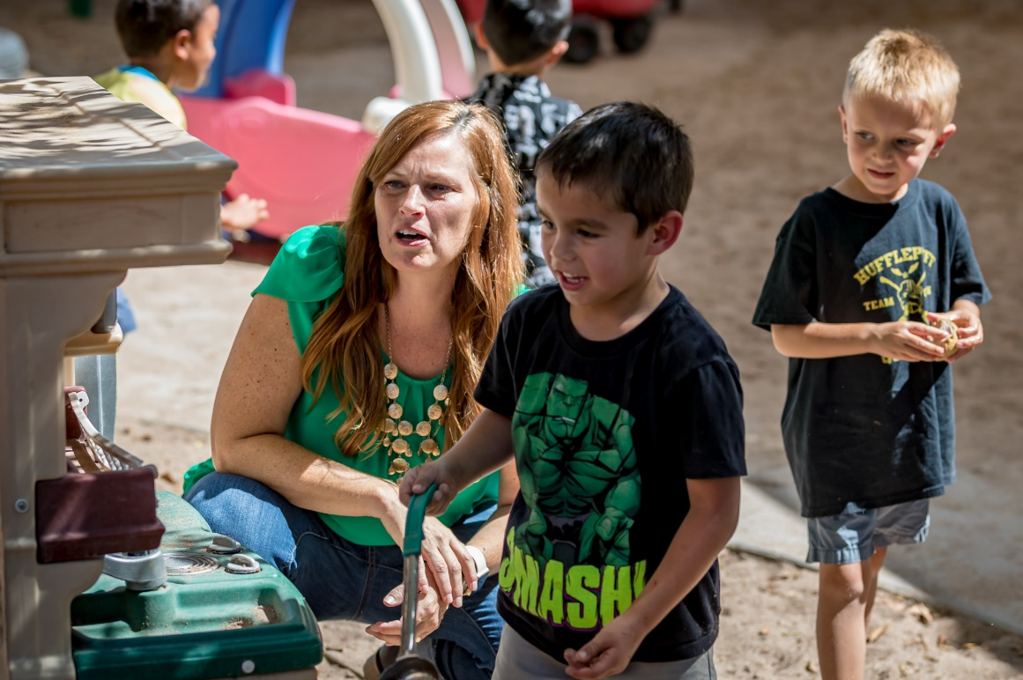
“My favorite part of teaching is to see how excited the children are to discover and learn new things!”
I chose Risen Savior because…
I wanted to be a part of a team that provides high quality care as well as providing an opportunity for children to learn through play. I wanted to have to opportunity to provide engaging learning experiences for every child.
Best part of the day
Anytime I observe a child or a group of children being curious, or discovering new skills, or having fun while learning through play. I suppose that is most of my day!
Favorite Children’s Book
“Hey Little Ant” by Phillip and Hannah Hoose. In this story, a child was trying to squish an ant but the ant was trying to talk him out of it. It’s a story about discussing a difference of opinion and introduces the idea of peer pressure, different points of view and unconditional respect.
What is the mud kitchen?
It is a fantastic hands-on sensory experience. Children to work together and problem-solve. I love observing children as they become engineers making roads or building dams, or artists creating mud hand prints and designs, or mathematicians who count and sort rocks. Children spend lots of time collaborating in the mud kitchen, too.
Young children have taught me...
That a smile can make your day and encouraging words can positively impact a life. Kindness is contagious and love is free. It’s alright to be wrong. (Even if you are the teacher.) Play is learning. Lastly, they have taught me that they are beautiful gifts, each and every one of them.
If I were a student at Risen Savior, you’d find me…
Either in the discovery table or the block area. If we were outside it would be the mud kitchen. I’d be building, making, pretending, and socializing with friends.
What I’ve learned from working with the Risen Savior Team
We can do anything, there hasn't been a challenge we could not manage. Great things happen when we work together.
What I want parents to understand
I am so lucky to spend the day with their child, playing together, watching new skills developing, and being a part of their lives. I strive to be connected not only with the children assigned to my class but also to their families. I gain this connection through sharing stories about their child's day.
Many people are surprised that young children...
Are so amazing! They experience rapid brain growth during the early years. The results of this brain growth will serve as a foundation for their future learning. To think this all happens by the age of eight. WOW! We have so much fun in our classroom everyday. Being a part of that energy is fantastic.

